**Full Stack Development with MERN**

**Frontend Development Report**

|  |  |
| --- | --- |
| Date | 17/07/2024 |
| Team ID | SWTID1720074953 |
| Project Name | Sb Foods - Food Ordering App |
| Maximum Marks |  |

**Project Title:** Sb Foods - Food Ordering App

Date:17/07/ 2024

Prepared by: K.Bhavana,Bodagala Gayathri,Bhuvaneswari K,P.Lahari

**Objective**

The objective of this report is to document the frontend development progress and key aspects of the user interface implementation for the project Sb Foods - Food Ordering App.

**Technologies Used**

* **Frontend Framework:** React.js
* **State Management:** **Context API**, Local Component State, Effect Hook (useEffect)
* **UI Framework/Libraries:** CSS, React Router, React Toastify
* **API Libraries:** Axios

**Project Structure**

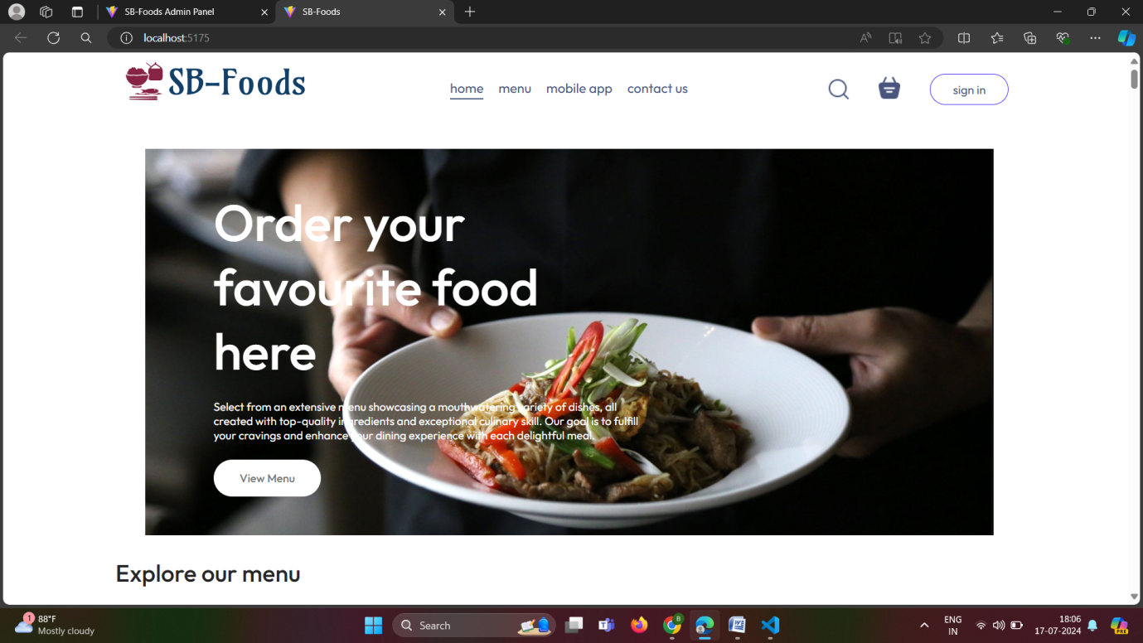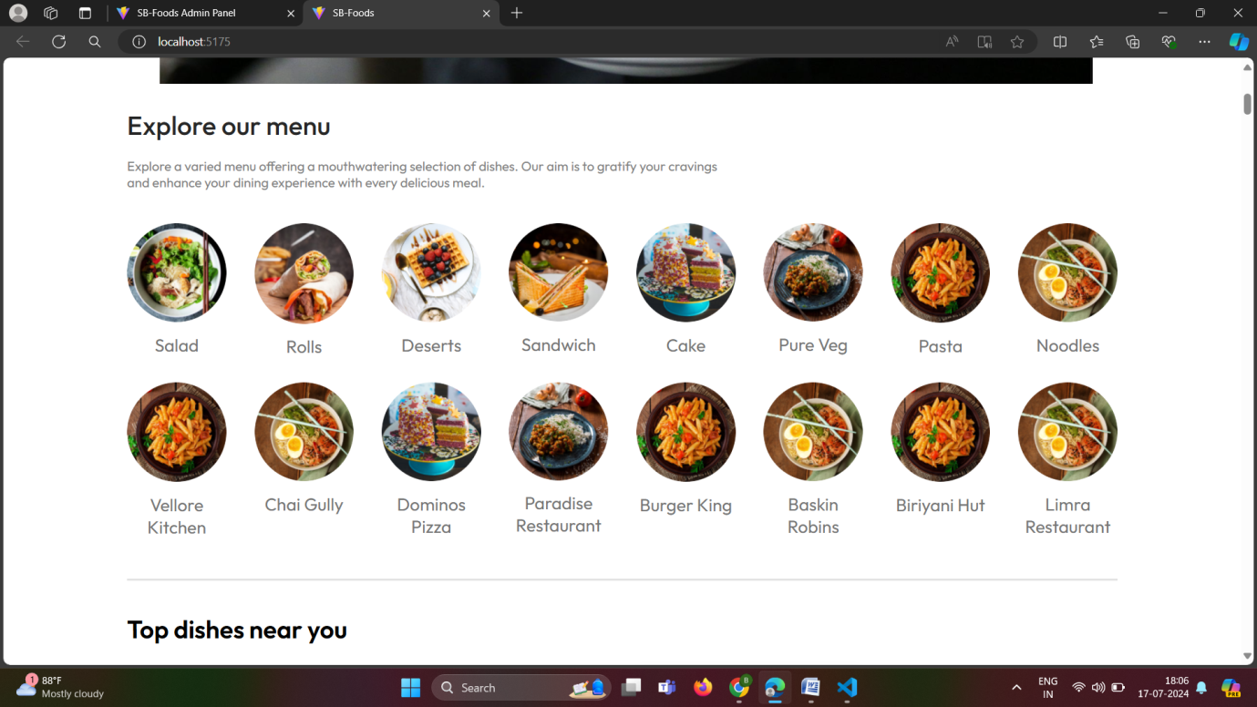

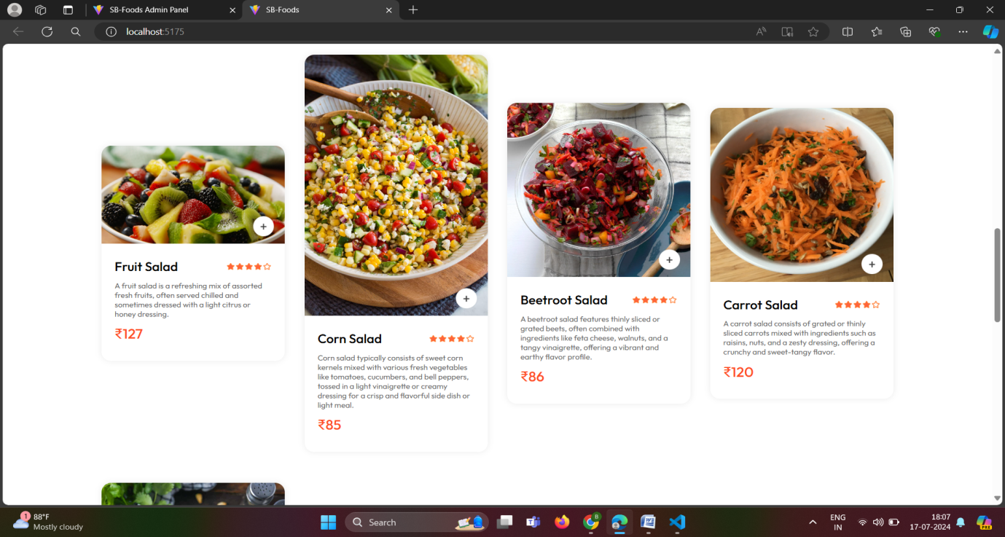

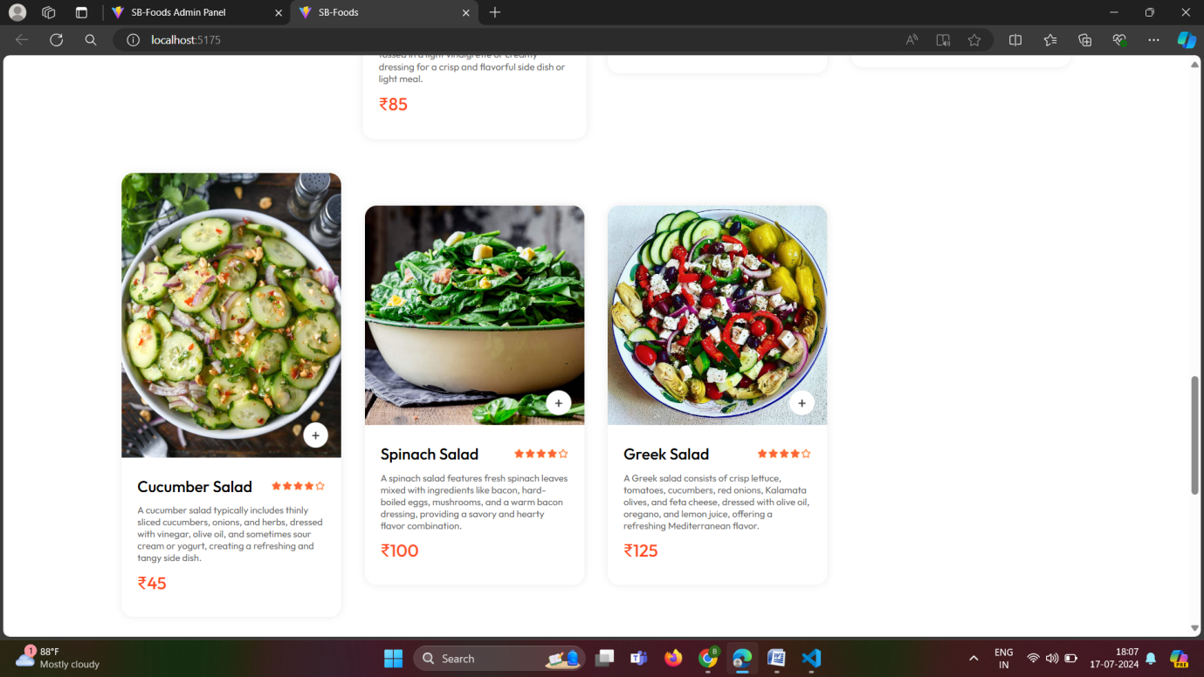

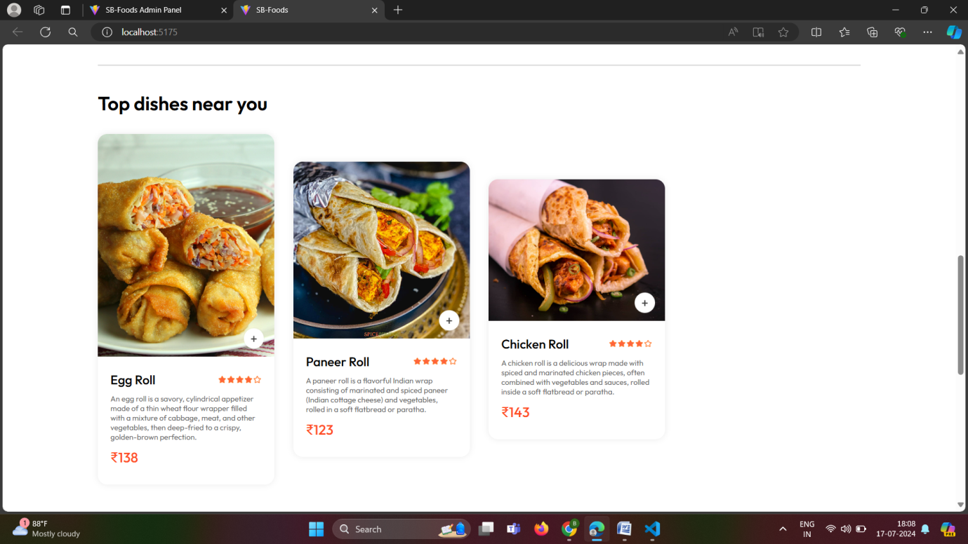

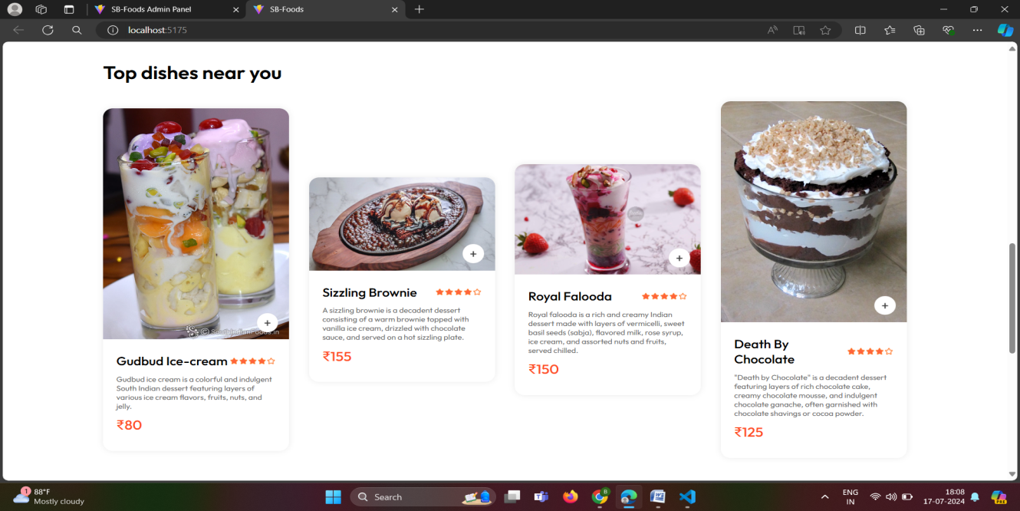

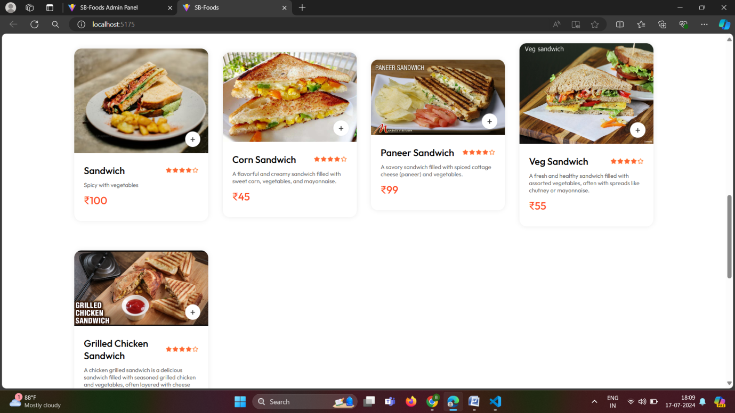

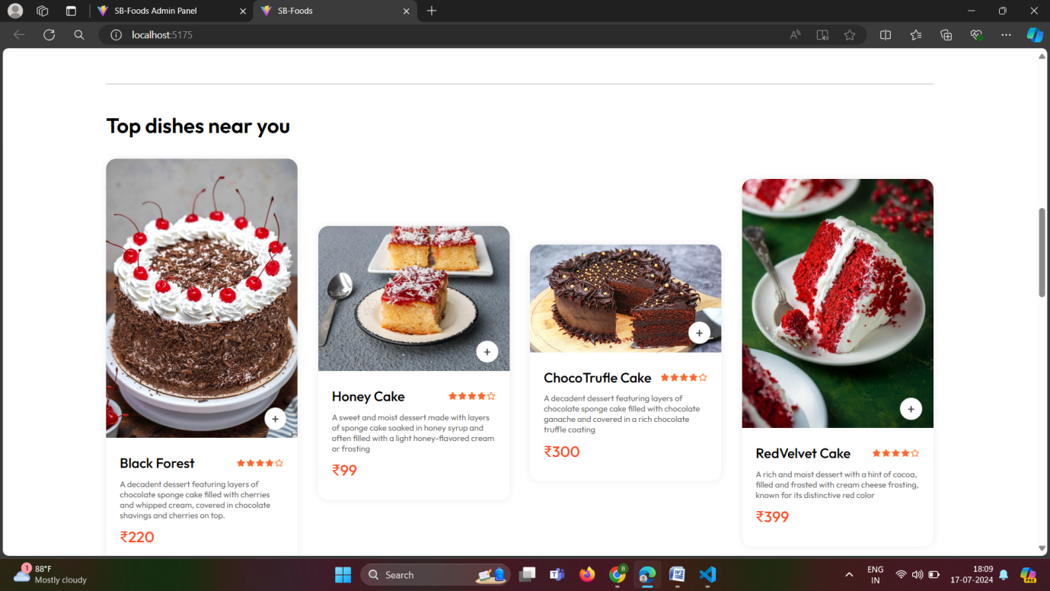

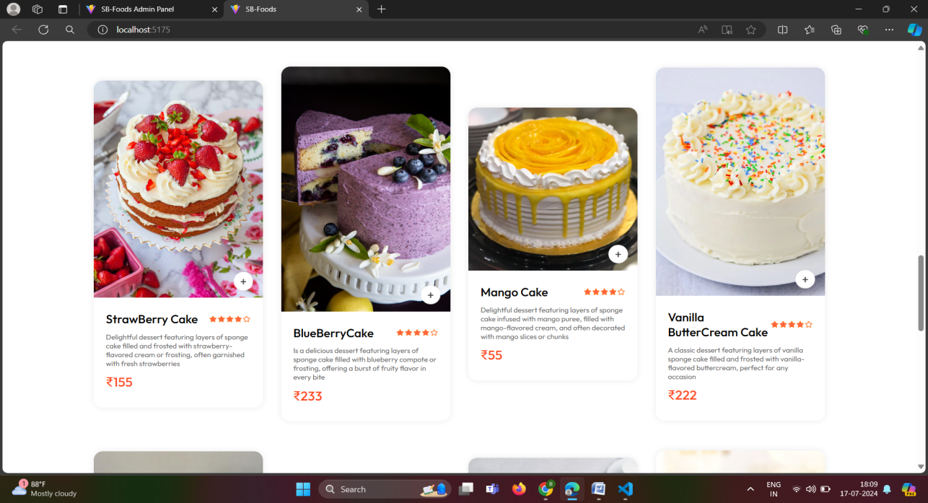

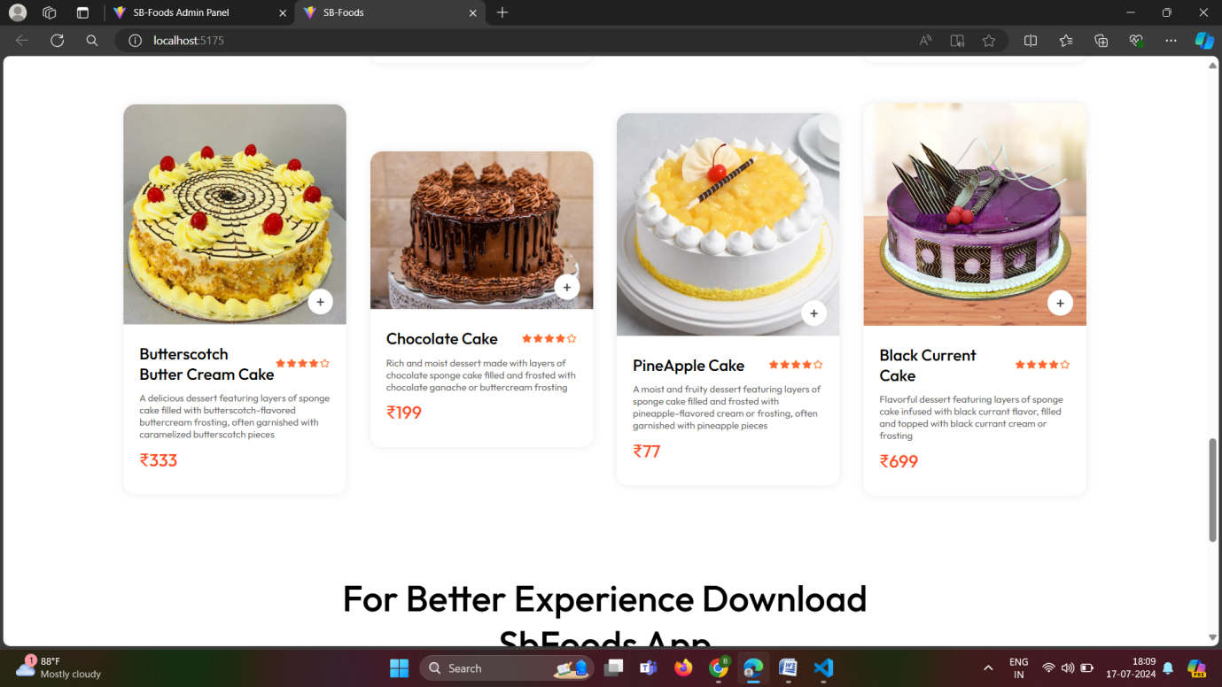

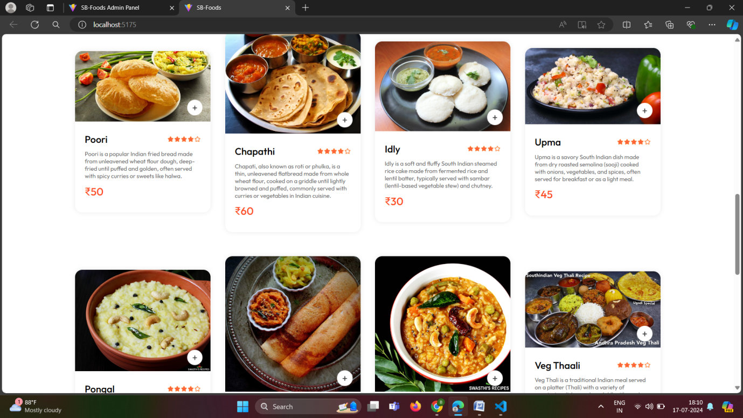

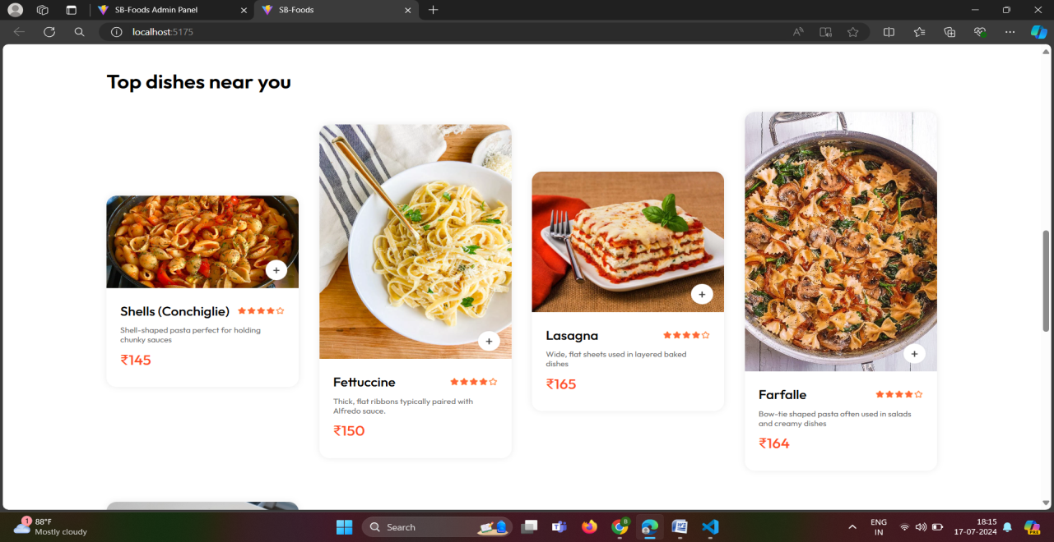

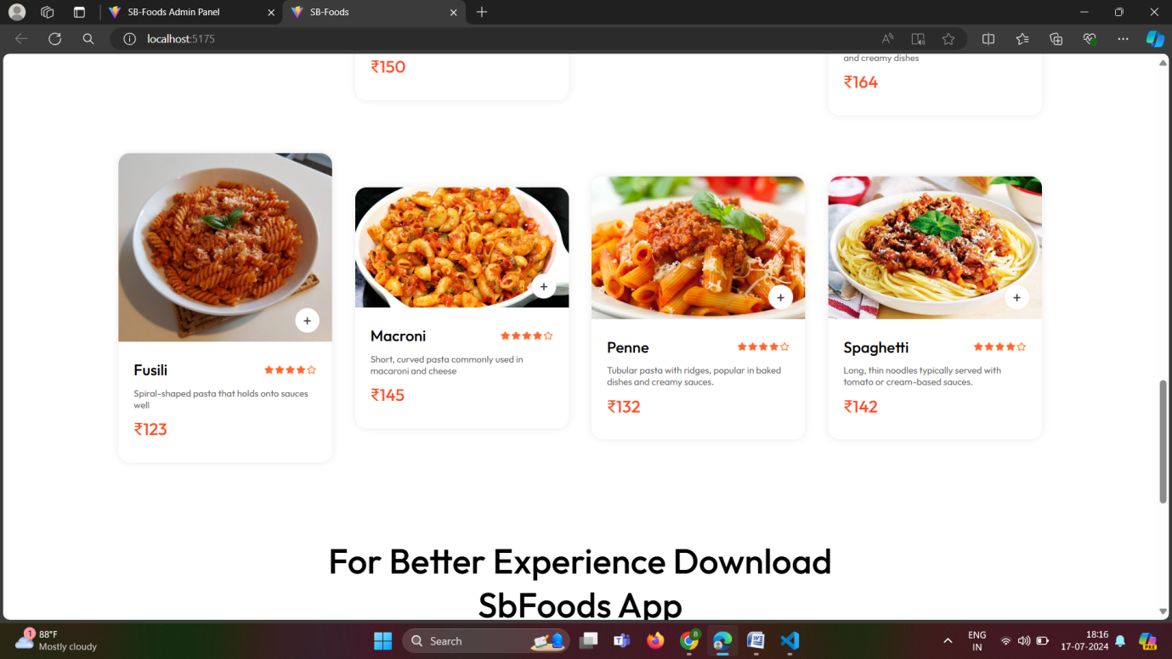

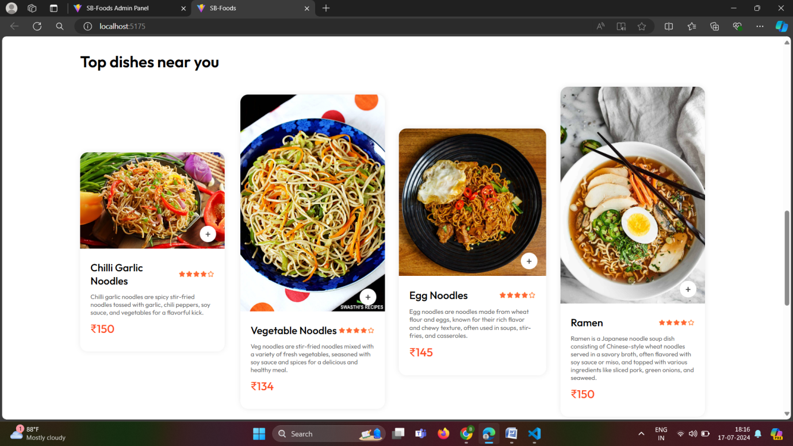

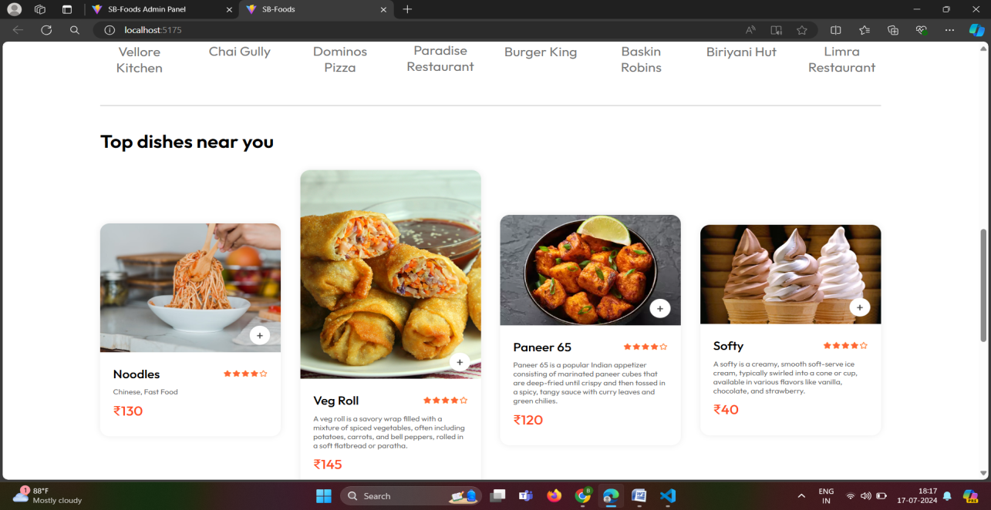

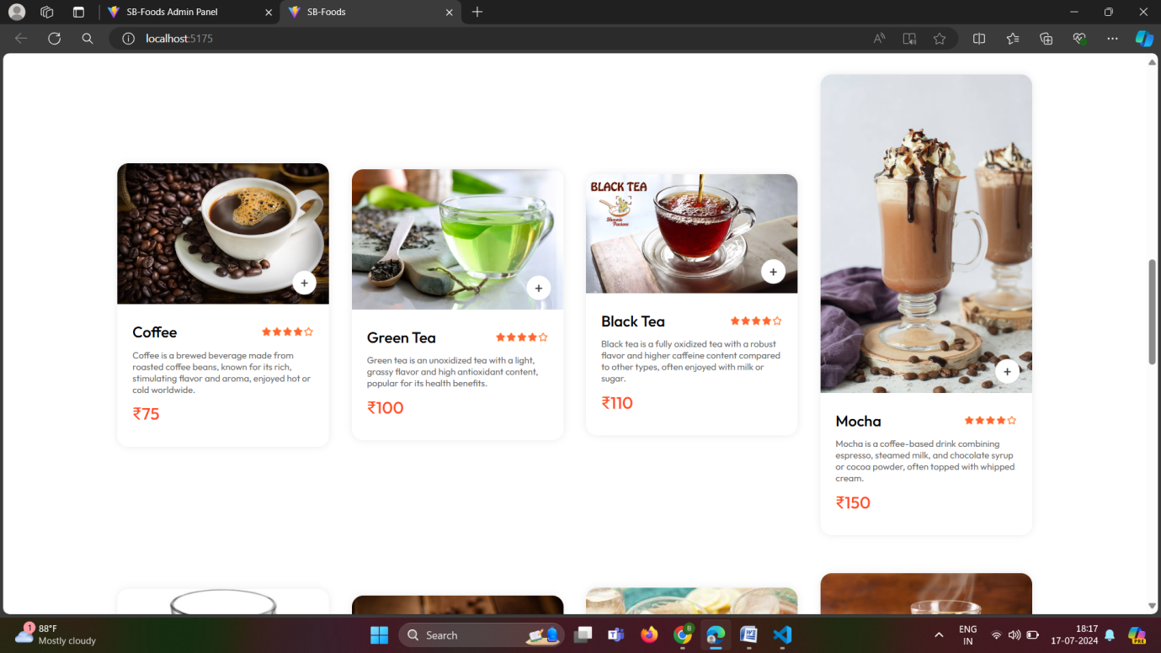

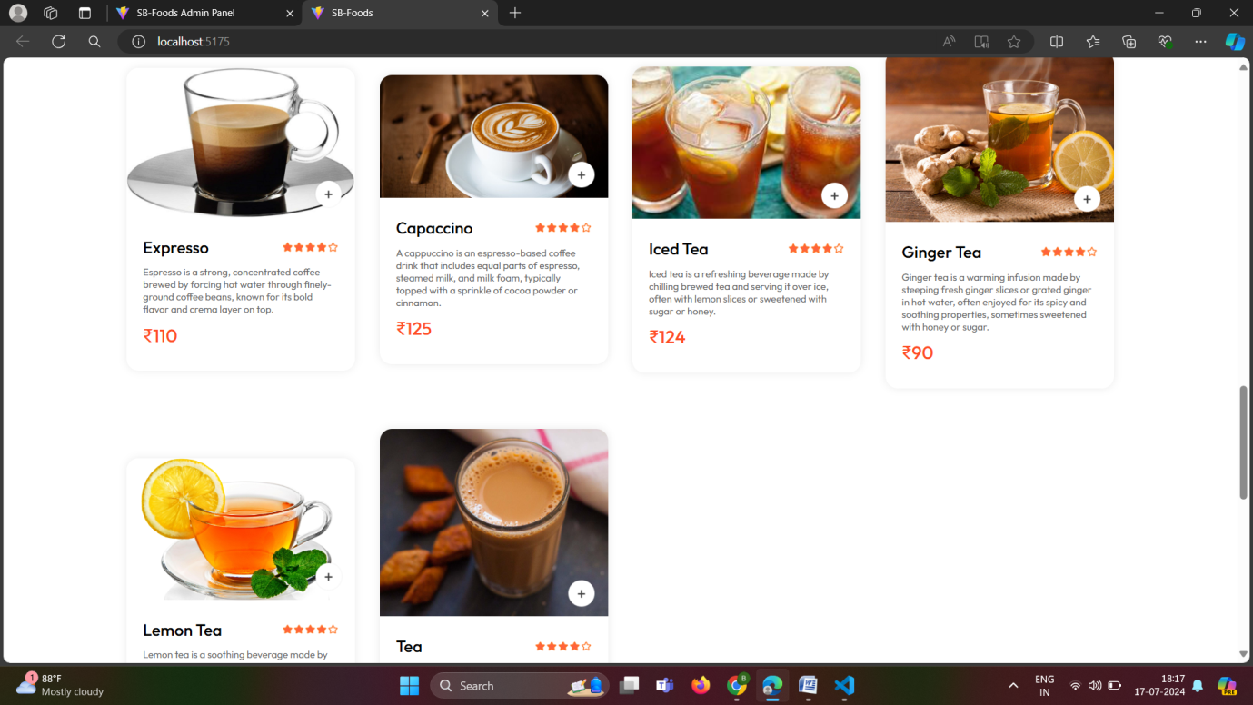

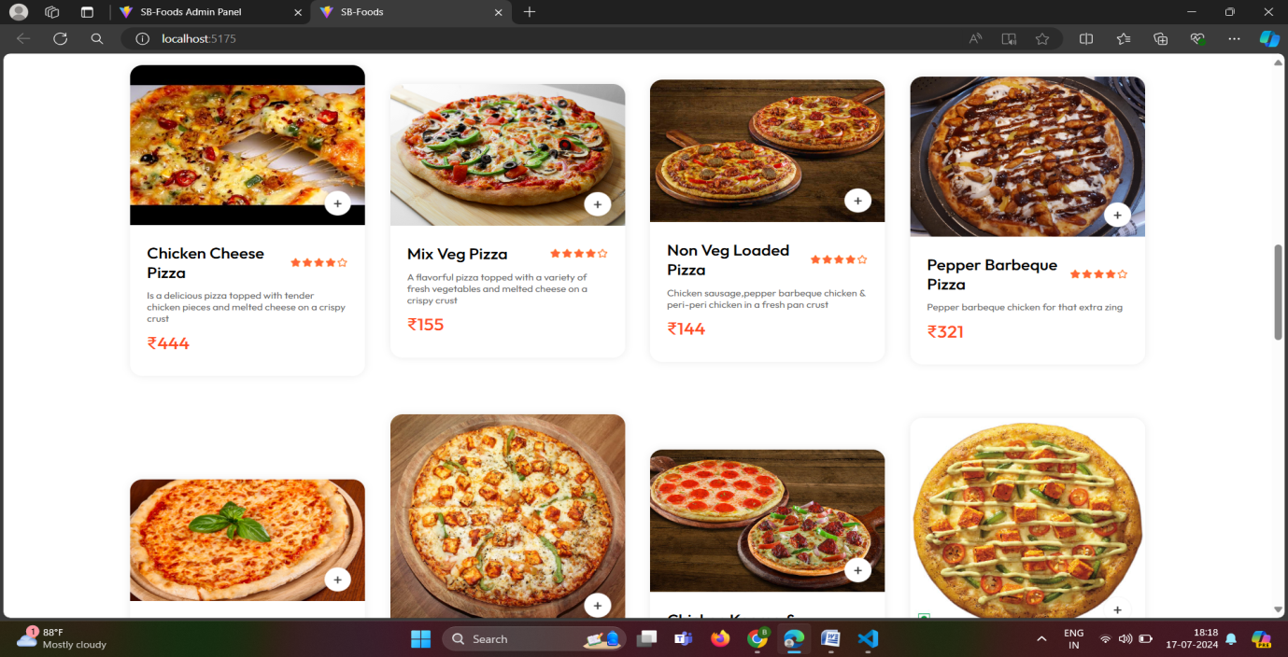

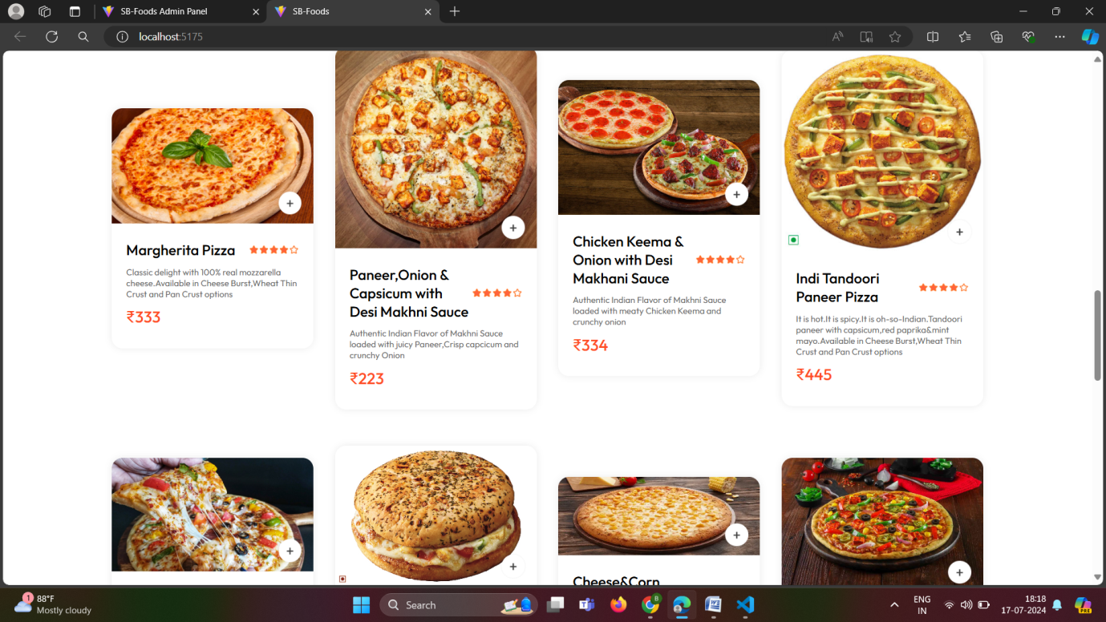

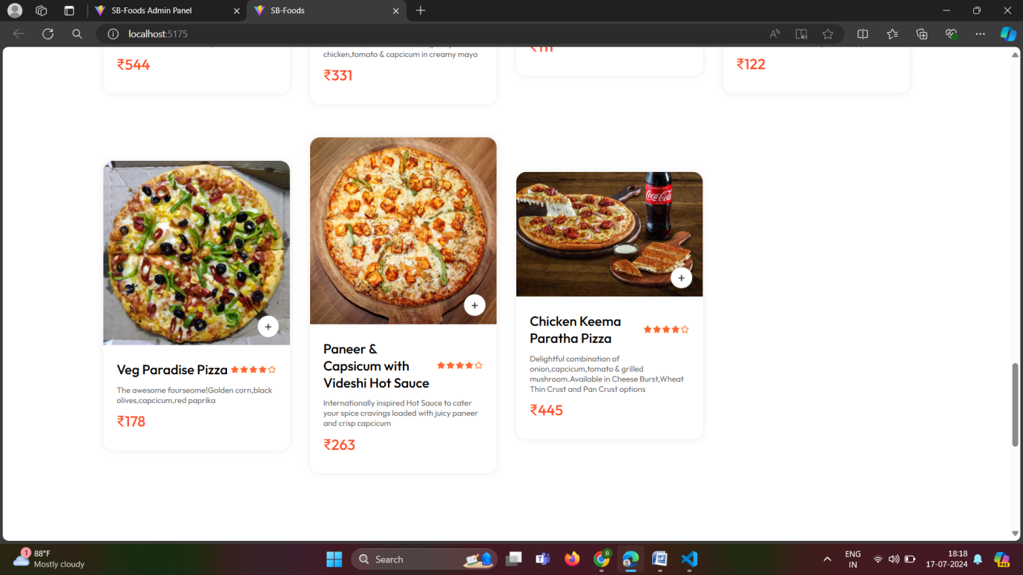

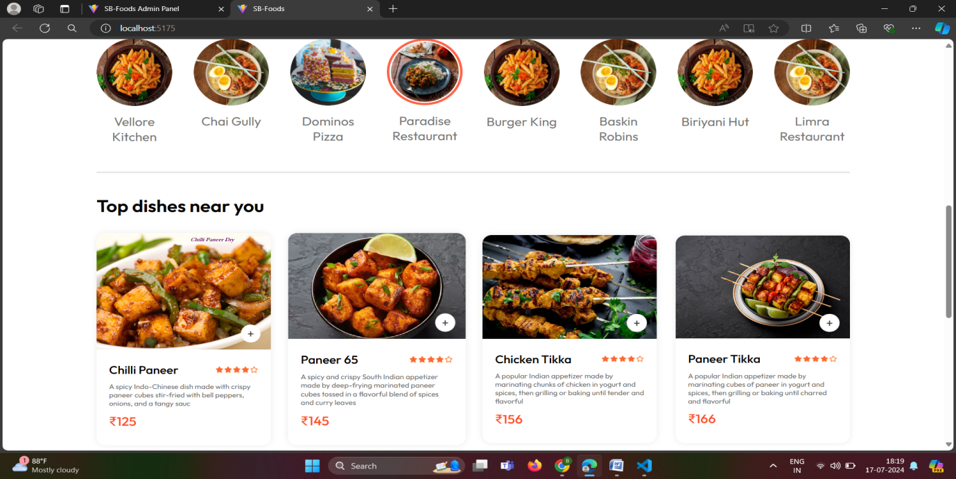

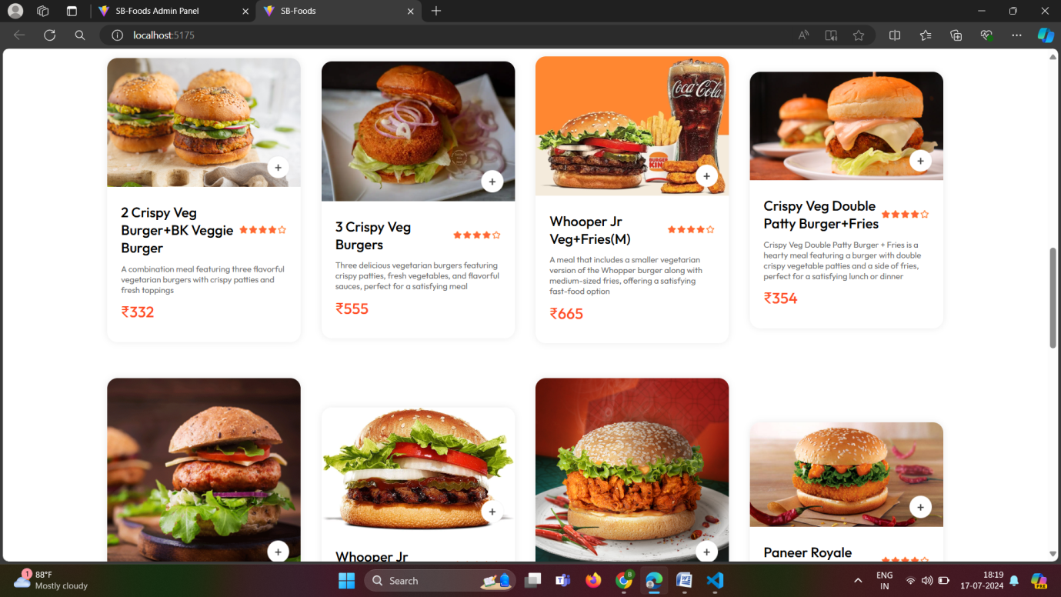

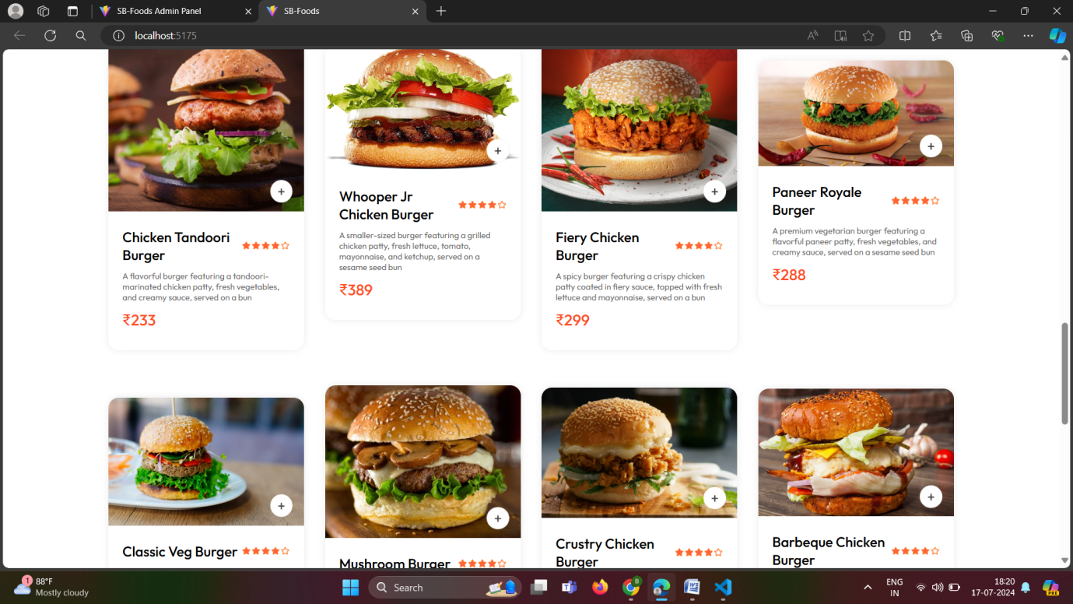

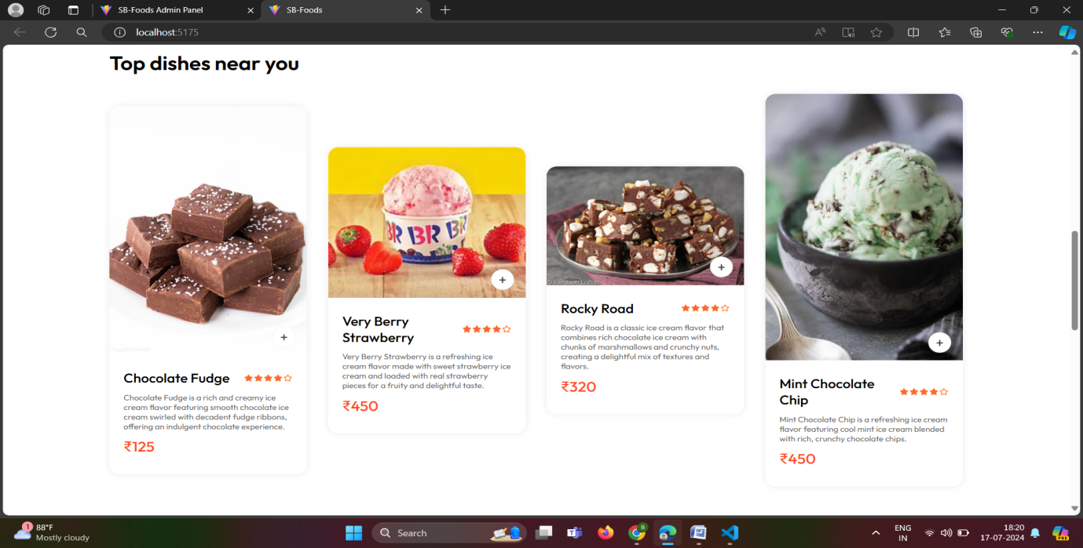

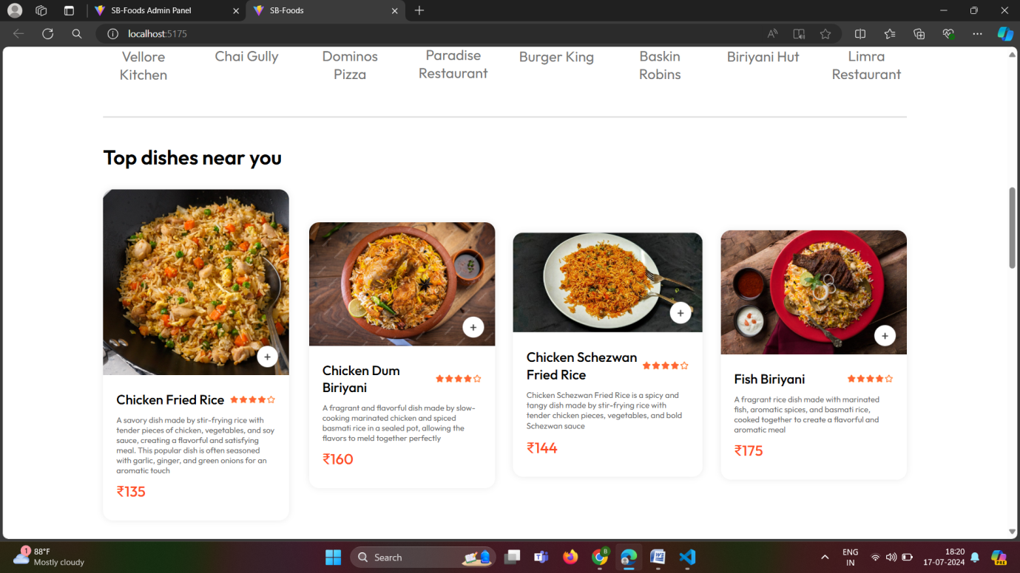

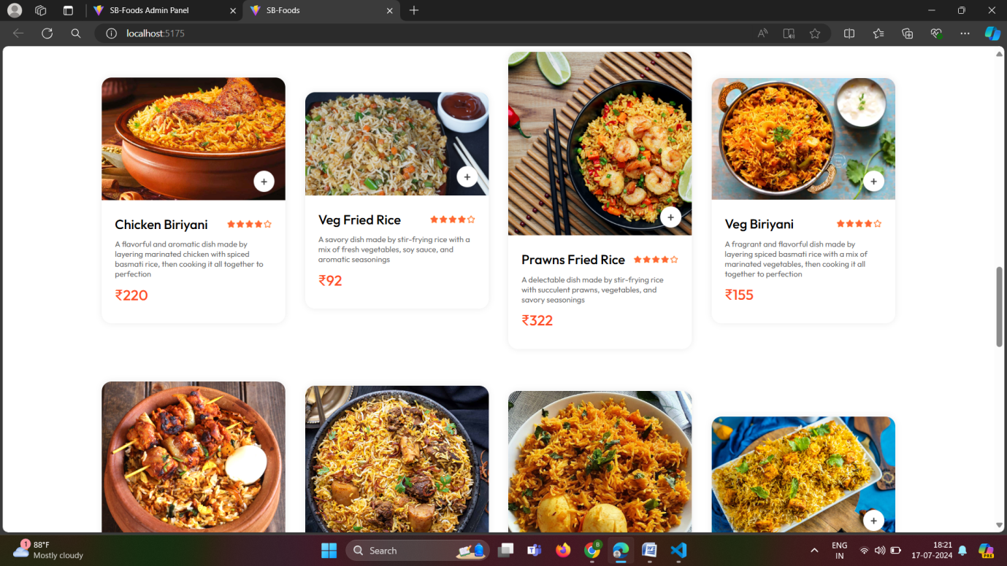

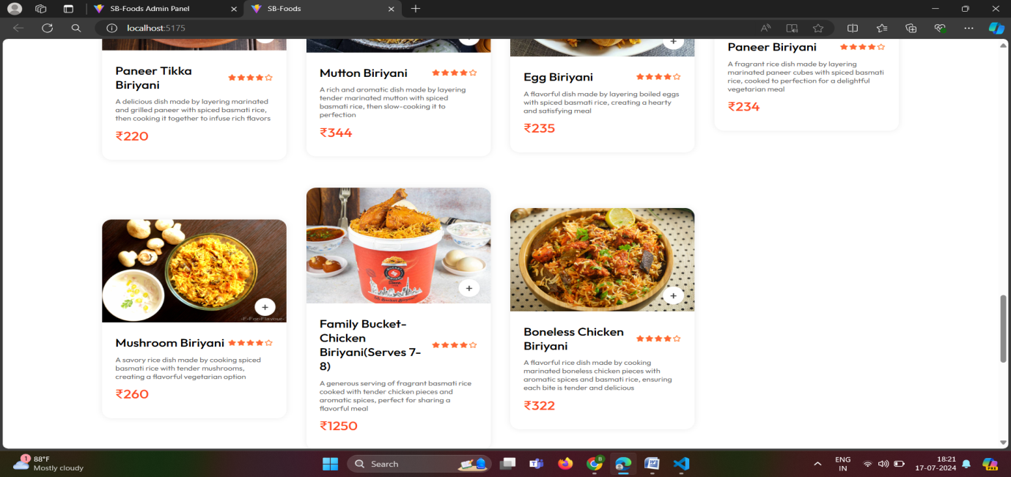

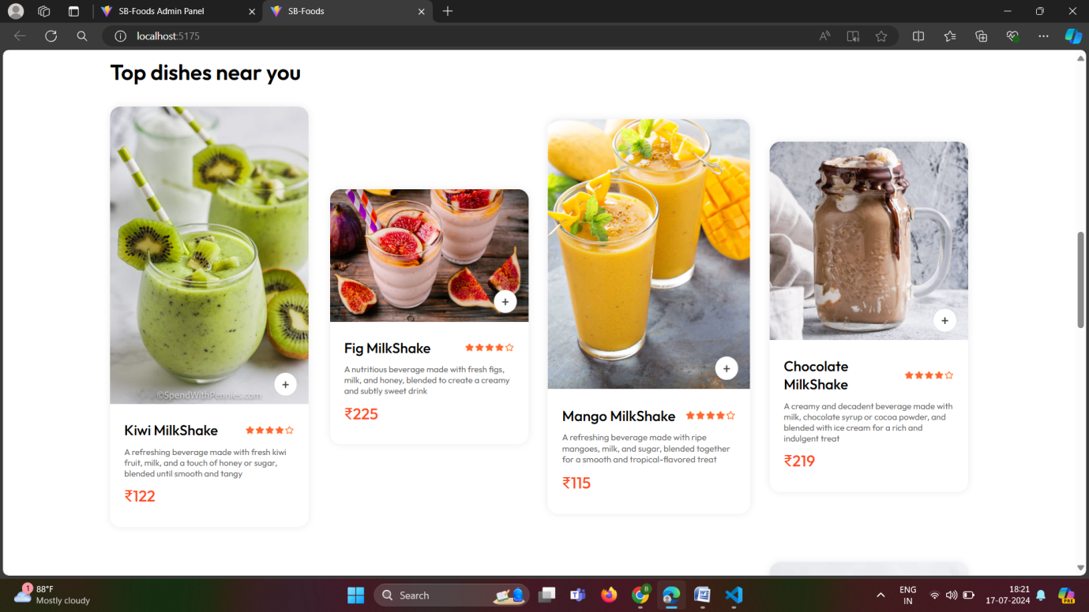

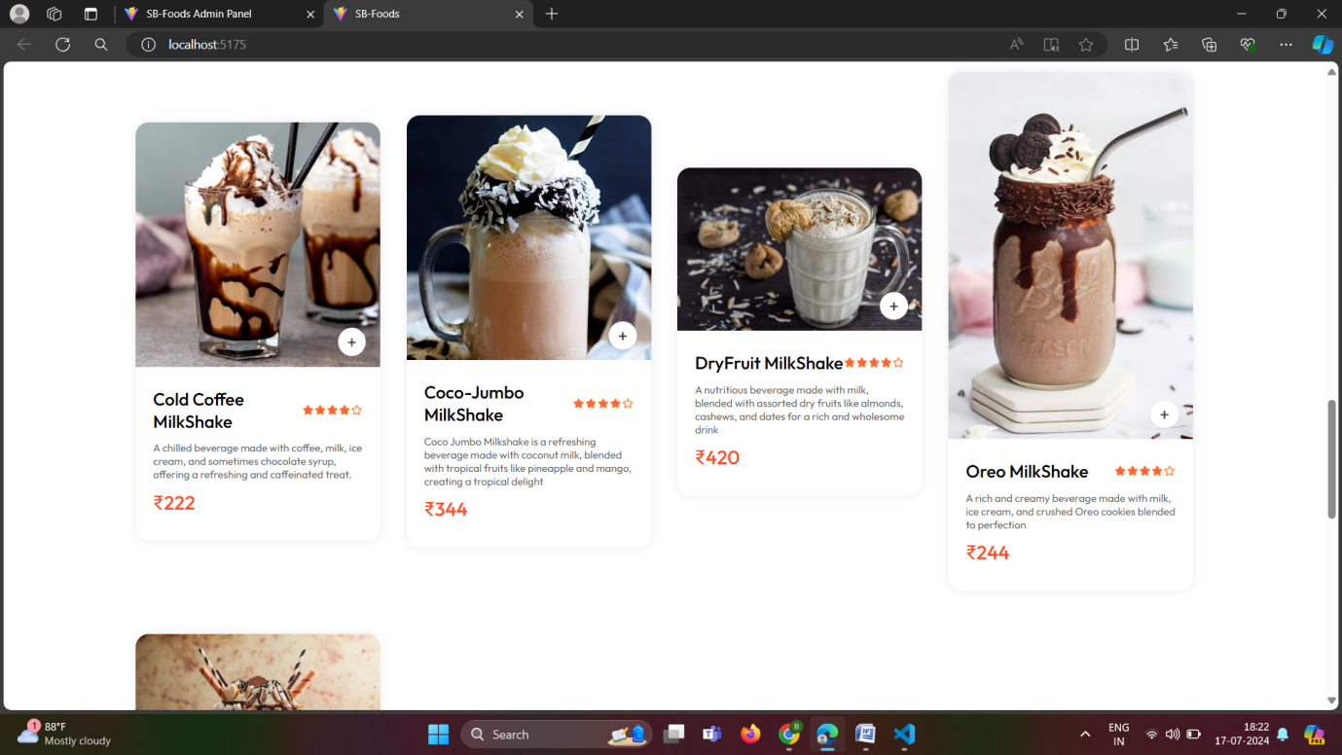

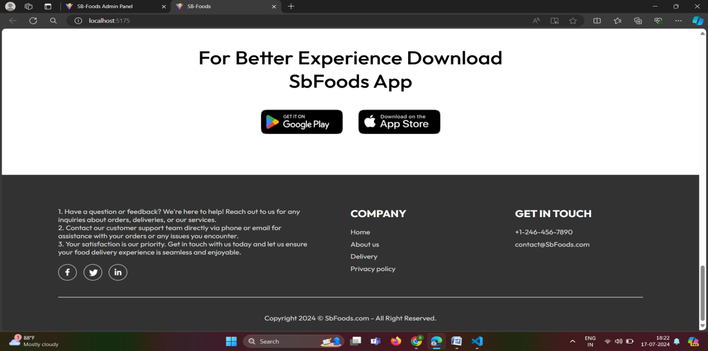

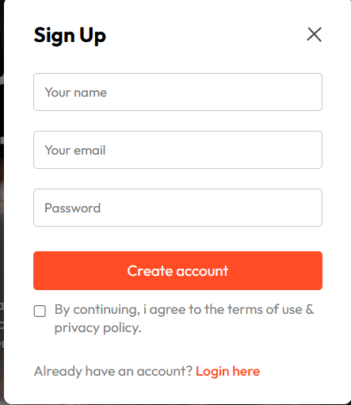

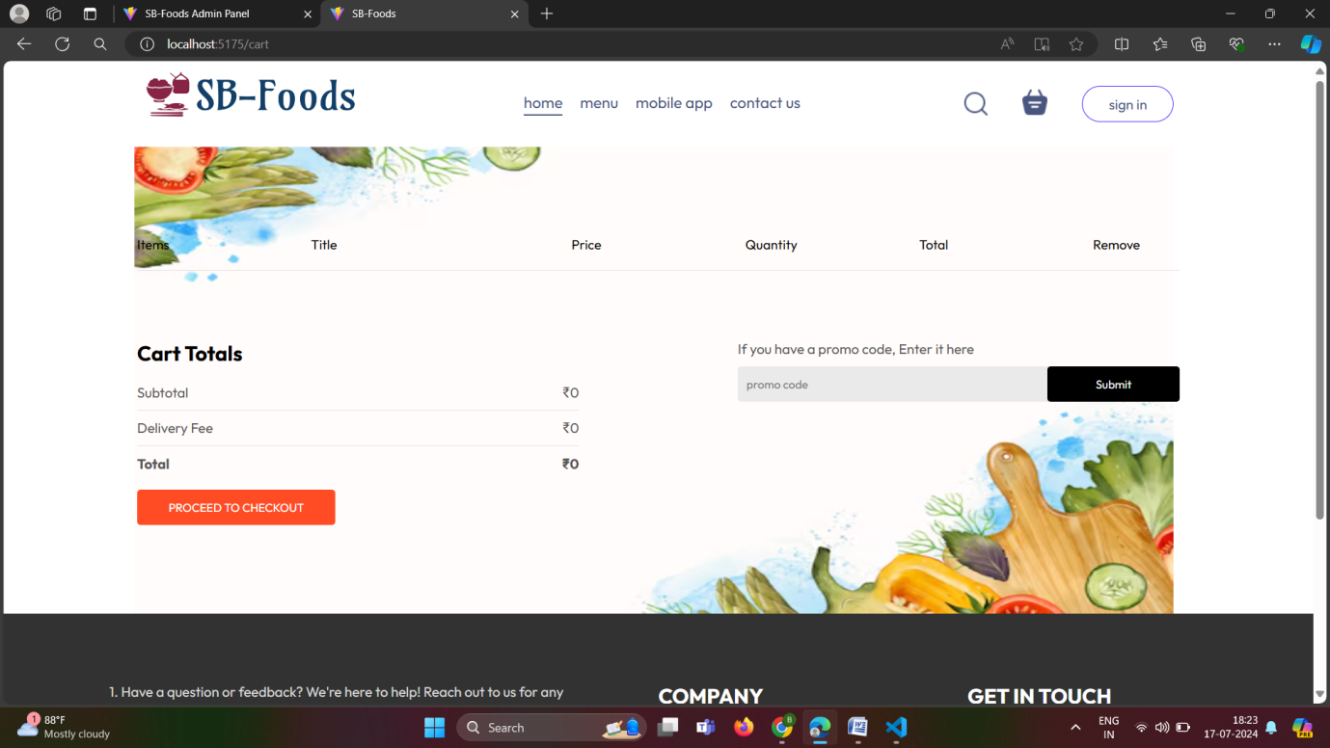

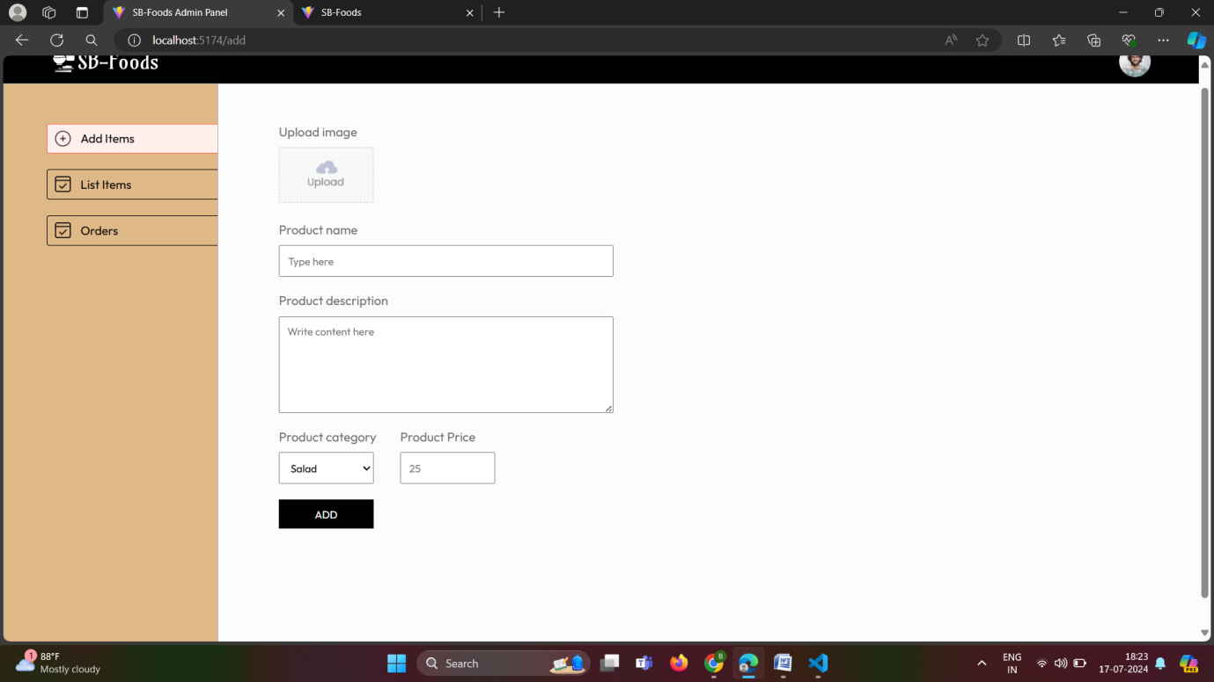

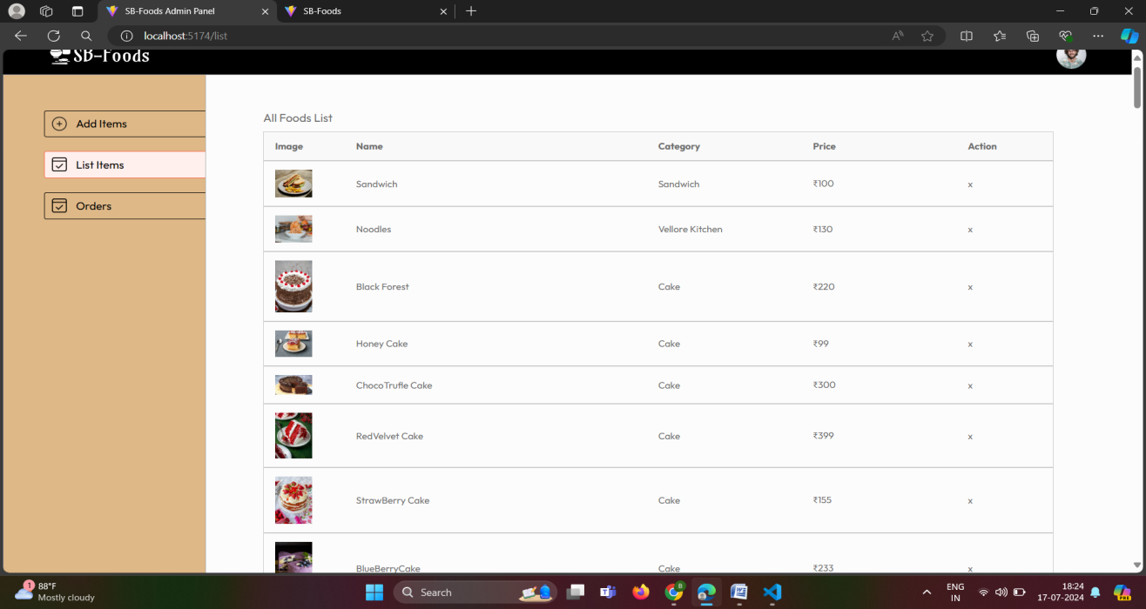

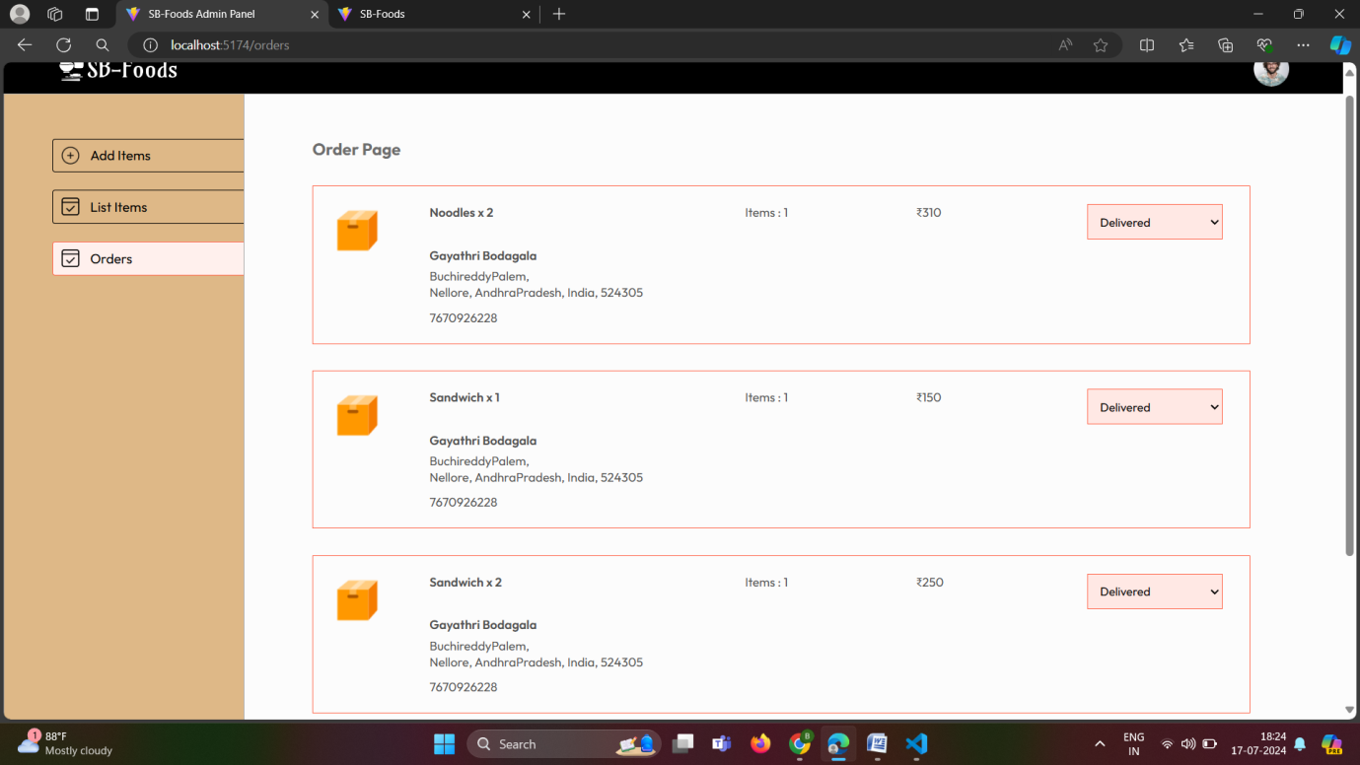

**Explanation:**

**Home Page**

* **Header:** Typically includes a logo and navigation links (e.g., Home, Cart, My Orders).
* **ExploreMenu:** A section where users can filter food items by categories such as All, Breakfast, Lunch, Dinner, Snacks, etc.
* **FoodDisplay:** Displays food items based on the selected category, showing images, names, and prices. Each item may have an "Add to Cart" button.
* **AppDownload:** Promotes downloading the mobile app for easier access to food ordering.

**Cart Page**

* **Header:** Similar to the home page header.
* **Cart Items:** Lists items added to the cart, displaying each item's image, name, price, quantity, total price, and an option to remove items.
* **Cart Totals:** Shows the subtotal, delivery fee, and total amount to be paid.
* **Promo Code:** Allows users to enter a promo code for discounts.
* **Proceed to Checkout Button:** Takes users to the order placement page.

**Place Order Page**

* **Delivery Information Form:** Form fields for entering delivery details like name, email, address, city, state, ZIP code, country, and phone number.
* **Cart Totals:** Displays the subtotal, delivery fee, and total amount.
* **Payment Method:** Options to select payment methods such as Cash on Delivery (COD) or Stripe (Credit/Debit Card).
* **Place Order Button:** Initiates the order placement process based on the selected payment method.

**My Orders Page**

* **Header:** Title "My Orders."
* **Order History:** Lists previous orders with details like order date, items ordered (name and quantity), total amount paid, number of items, and current order status (e.g., Pending, Delivered).
* **Track Order Button:** Allows users to track the status of each order.

**Verify Page**

* **Loading Indicator:** Displays a loading spinner or indicator while verifying payment status.

**Navbar**

* **Logo:** Application logo linking back to the home page.
* **Navigation Links:** Links such as Home, Cart (with item count indicator), My Orders, and possibly others like Profile or Settings.
* **Search Bar:** Allows users to search for specific food items or categories.
* **User Authentication:** Displays a sign-in button or user profile information based on whether the user is logged in.

**Footer**

* **Links:** Includes links to legal information (Privacy Policy, Terms of Service), contact details, and possibly social media links.
* **App Download Links:** Provides links to download the mobile app for Android and iOS.

**Login Popup**

* **Modal:** A modal or popup that appears when users click on the sign-in button in the Navbar, allowing users to log in or register.

**Key Components**

1. **App.js**

* **Routing (`react-router-dom`):** `App.js` sets up routing using `Routes` and `Route` components from `react-router-dom`. Each `Route` defines a path and specifies which component to render when the URL matches that path. For example:

- `/` renders the `Home` component.

- `/cart` renders the `Cart` component.

- `/order` renders the `PlaceOrder` component.

- `/myorders` renders the `MyOrders` component.

- `/verify` renders the `Verify` component.

* **State Management:** Manages the `showLogin` state using `useState`. This state determines whether the `LoginPopup` component should be displayed (`true`) or hidden (`false`).
* **Component Composition:** Wraps the entire application within a `ToastContainer` from `react-toastify`, enabling toast notifications throughout the application. The `Navbar`, `Routes`, and `Footer` components are also rendered within the `App` component, providing a consistent layout and navigation structure across different pages.
* **Integration**: Integrates various components (`Navbar`, `Footer`, `LoginPopup`, `Home`, `Cart`, `PlaceOrder`, `MyOrders`, `Verify`) to create a cohesive user interface and user experience for the application.
* **Lifecycle Management**: While not explicitly shown in this snippet, `App.js` can also manage global state using context providers (`StoreContextProvider` or similar) or handle global configurations and initialization logic for the entire application.

1. **/components**

**1. Home:** Renders the main landing page of the food app. It includes the header, explores menu options, displays food items based on selected categories, and promotes app download options.

**2. Footer:** Provides the footer section with relevant links and information.

**3. Navbar:** Displays the navigation bar at the top of the app, allowing users to navigate between different sections like Home, Cart, Place Order, My Orders, and Verify.

**4. Cart:** Manages the display of items added to the cart, allows users to update quantities or remove items, calculates totals including delivery charges, and provides a button to proceed to checkout.

**5. LoginPopup:** Handles the display and functionality of the login popup when triggered by user action.

**6. PlaceOrder:** Manages the process of placing an order, including collecting user delivery information, selecting payment methods (Cash on Delivery or Stripe), and submitting the order to the backend.

**7. MyOrders:** Displays a list of orders placed by the logged-in user, showing order details such as items, total amount, quantity, and current status. It also allows users to track their orders.

**8. Verify:** Handles the verification of payment status for Stripe payments and redirects users accordingly based on the payment verification outcome.

Each component plays a specific role in creating a cohesive user interface for the food app, managing different aspects of user interaction from browsing food items to placing orders and managing user accounts.

1. **/pages**

**Home**: This is the landing page of the application where users can explore food items categorized under different sections.

**Cart**: Displays the items added to the cart, allows users to modify quantities or remove items, and shows the total amount including delivery charges.

**PlaceOrder**: This page facilitates the checkout process where users enter their delivery information, select a payment method (either Cash on Delivery or Stripe), and confirm their order.

**MyOrders**: Shows a list of orders placed by the user, including details like ordered items, total amount, quantity, and order status. It also provides a button to track each order.

**Verify**: Handles the verification of payment status for Stripe payments and redirects users based on the payment verification outcome.

These pages together form the core user journey for browsing, selecting, ordering, and managing food items within the application. Each page serves a distinct purpose in enhancing the user experience and facilitating smooth interaction with the food ordering system.

**Routing**

Routing is managed using React Router. Here are the main routes:

**Home Page (/)**:

* This is the landing page of the application.
* Rendered using <Route path='/' element={<Home />} />.

**Cart Page (/cart)**:

* Displays the items added to the cart.
* Rendered using <Route path='/cart' element={<Cart />} />.

**Place Order Page (/order)**:

* Facilitates the checkout process.
* Allows users to enter delivery information and select a payment method.
* Rendered using <Route path='/order' element={<PlaceOrder />} />.

**My Orders Page (/myorders)**:

* Shows a list of orders placed by the user.
* Provides order details and tracking options.
* Rendered using <Route path='/myorders' element={<MyOrders />} />.

**Verify Page (/verify)**:

* Handles payment verification after placing an order.
* Redirects based on the payment verification outcome.
* Rendered using <Route path='/verify' element={<Verify />} />.
* .**State Management (If Applicable)**

**1. Local Component State:**

- `App` Component: Manages the state for `showLogin`, which controls whether the login popup is displayed (`useState` hook).

- `PlaceOrder` Component: Uses `useState` to manage local state for `payment` and `data`, handling user input for delivery information and payment method selection.

**2. Context API (Global State):**

**- `StoreContext`:** Provides global state management through context API, making data accessible across components without prop drilling.

**- State Variables Managed:**

- `food_list`, `cartItems`, `token`, `currency`, `deliveryCharge`, etc., are managed centrally in the `StoreContextProvider` component.

- Functions like `addToCart`, `removeFromCart`, `getTotalCartAmount`, `loadCartData`, etc., are also defined in `StoreContextProvider` to update and retrieve global state.

**3. Effect Hooks:**

**- `useEffect` Hook:** Used in various components (`MyOrders`, `Verify`, `PlaceOrder`, etc.) to manage side effects such as fetching data (`fetchOrders`, `verifyPayment`), handling navigation (`navigate`), and updating state based on dependencies (`token`, `getTotalCartAmount`, etc.).

**4. Routing State:**

**- `react-router-dom`:** Manages navigation state between different pages (`Home`, `Cart`, `PlaceOrder`, `MyOrders`, `Verify`) using `<Routes>` and `<Route>` components.

- Each route component (`<Home />`, `<Cart />`, etc.) receives props and interacts with the application state accordingly.

**Integration with Backend**

**1. MongoDB Database Integration:**

- Mongoose: Used for defining schemas and models, and interacting with MongoDB databases. Mongoose provides a straightforward way to define schemas, perform CRUD operations, and enforce data validation.

**2. Express.js Framework:**

- Routing: Express.js is commonly used to define API endpoints (`GET`, `POST`, `PUT`, `DELETE`) that handle HTTP requests from the frontend. It manages middleware functions for processing requests and responses.

- Middleware: Middleware functions are utilized for tasks such as authentication (`authMiddleware`), error handling, request parsing, and more.

**3. JWT (JSON Web Token) Authentication:**

- jsonwebtoken: Used for creating and verifying JWT tokens (`createToken`, `authMiddleware`). JWT tokens are typically issued upon successful user authentication and used to authorize subsequent API requests.

**4. Stripe Payment Gateway Integration:**

- Stripe: Integrated for handling payment transactions (`placeOrder`, `placeOrderCod`). Stripe provides APIs and libraries for securely processing online payments, including credit card payments and other payment methods.

**5. File System Handling:**

- fs (File System)**: Used for file operations such as uploading (`addFood`) and deleting (`removeFood`) files from the server. In the provided context, it's used to manage food images stored in the `uploads` directory.

**6. Environment Variables:**

- dotenv: Used for loading environment variables from a `.env` file (`process.env.JWT_SECRET`, `process.env.STRIPE_SECRET_KEY`). This practice enhances security by keeping sensitive information like API keys and secrets outside of source code repositories.

**7. Error Handling:**

- Errors are caught and logged (`console.log(error)`) throughout the backend code (`try-catch` blocks), ensuring robustness by handling exceptions gracefully and providing meaningful error messages in API responses (`res.json({ success: false, message: "Error" })`).

**User Interface (UI) Design**

**1. Home Page (`/` route):**

- Likely displays various food items or categories.

- Includes navigation to other sections like the cart, order placement, and user's orders.

- May feature promotional banners or special offers.

2. Cart Page (`/cart` route):

- Shows items added to the cart.

- Allows users to adjust quantities or remove items.

- Displays the total amount including delivery charges.

3. Place Order Page (`/order` route):

- Provides a form for users to input their delivery address.

- Shows a summary of items in the cart.

- Includes options for payment method selection (possibly integrated with Stripe for online payment).

4. My Orders Page (`/myorders` route):

- Lists orders placed by the logged-in user.

- Each order entry displays details like order ID, items, status, and delivery address.

- Provides functionality to track order status and manage orders (if applicable).

5. Verification Page (`/verify` route):

- Redirects after a payment attempt.

- Displays a loading spinner indicating processing.

- Updates based on payment success or failure, navigating to appropriate pages (`/myorders` on success or homepage on failure).

- Navigation: A fixed navbar (possibly with a responsive design) facilitates easy access to different sections of the application.

- Responsive Design: Likely utilizes responsive frameworks or custom CSS to ensure usability across different devices and screen sizes.

- Toast Notifications:Uses `react-toastify` or similar for displaying alerts or notifications, such as successful actions or errors.

- Modal/Popup: Includes a login popup (`LoginPopup` component) for user authentication without leaving the current page.

- Styling: The application may employ custom CSS (`index.css`, `Verify.css`, etc.) for consistent styling across components.

**Third-Party Integrations (If any)**

**1. Stripe for Payment Processing:**

- Used in `placeOrder` and `placeOrderCod` functions to handle online payments securely.

- Integration involves creating checkout sessions (`stripe.checkout.sessions.create`) and processing payments (`mode: 'payment'`).

**2. React-Toastify:**

- Utilized for displaying notifications to users (`ToastContainer`) regarding successful actions or errors.

- Integrated with `react-toastify/dist/ReactToastify.css` for styling.

**3. MongoDB (via Mongoose):**

- Although not strictly a third-party service, it's a cloud-based database service commonly used.

- `mongoose` is used to define and interact with schemas (`foodModel`, `userModel`, `orderModel`) that store data persistently.

**4. jsonwebtoken (JWT):**

- Used for user authentication (`createToken`, `loginUser`, `authMiddleware`) by generating tokens to verify user identity securely.

**5. axios:**

- Facilitates HTTP requests (`axios.post`, `axios.get`) to interact with backend APIs (`/api/order/verify`, `/api/data`, `/api/user/login`, etc.).

**6. Express.js (implicitly via Node.js):**

- Handles server-side logic for routing, middleware (`authMiddleware`), and API handling.

**7. bcrypt:**

- Provides password hashing (`bcrypt.genSalt`, `bcrypt.hash`) for secure storage in the database (`registerUser`, `loginUser`).